E-commerce website

Definition:
# Source: AI Source: Provided by: [Data Path: Persons Table -> ID Column: 1, Name_En Column: Motasem Essam] -> From: [Chatgpt (GPT‑5 Mini)] on [2/12/2026]
An e-commerce website is a website where people can buy and sell products or services online. It’s essentially an online store.

Simple Definition
# Source: AI Source: Provided by: [Data Path: Persons Table -> ID Column: 1, Name_En Column: Motasem Essam] -> From: [Chatgpt (GPT‑5 Mini)] on [2/12/2026]
E-commerce website = a digital shop where transactions happen over the internet.

What an E-commerce Website Usually Includes
# Source: AI Source: Provided by: [Data Path: Persons Table -> ID Column: 1, Name_En Column: Motasem Essam] -> From: [Chatgpt (GPT‑5 Mini)] on [2/12/2026]
- Home page – featured products or categories
- Product pages – details, images, price, reviews
- Shopping cart – where customers add items before buying
- Checkout / Payment – pay using credit cards, PayPal, or other methods
- User accounts – track orders, wishlist, personal info
- Order tracking / Shipping info – updates on deliveries

Examples of E-commerce Websites
# Source: AI Source: Provided by: [Data Path: Persons Table -> ID Column: 1, Name_En Column: Motasem Essam] -> From: [Chatgpt (GPT‑5 Mini)] on [2/12/2026]
- Amazon – sells almost everything online
- eBay – online marketplace
- Etsy – handmade and creative goods
- Walmart.com – physical store online

Features of E-commerce Websites
# Source: AI Source: Provided by: [Data Path: Persons Table -> ID Column: 1, Name_En Column: Motasem Essam] -> From: [Chatgpt (GPT‑5 Mini)] on [2/12/2026]
- Online catalog of products
- Secure payment system
- Inventory management
- User accounts & login
- Order processing & tracking
- Customer reviews

Purpose of an E-commerce Website
# Source: AI Source: Provided by: [Data Path: Persons Table -> ID Column: 1, Name_En Column: Motasem Essam] -> From: [Chatgpt (GPT‑5 Mini)] on [2/12/2026]
- Sell products or services online
- Reach customers globally, 24/7
- Reduce the need for a physical store
- Simplify ordering and payment process
- Collect customer data for marketing

Difference from Other Websites
# Source: AI Source: Provided by: [Data Path: Persons Table -> ID Column: 1, Name_En Column: Motasem Essam] -> From: [Chatgpt (GPT‑5 Mini)] on [2/12/2026]
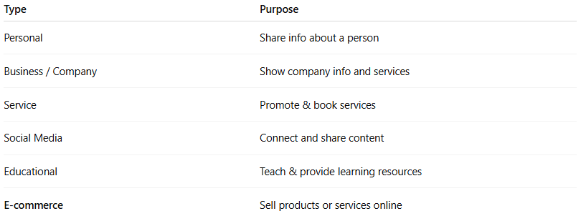
Type | Purpose
Personal | Share info about a person
Business / Company | Show company info and services
Service | Promote & book services
Social Media | Connect and share content
Educational | Teach & provide learning resources
E-commerce | Sell products or services online

